CCAGGMM Program

Referred manuscript title: "Confidence-Constrained Asymmetric Generalized Gaussian Mixture Model for Spectral Decomposition in Well Logging".

(1) The primary objective of the program
The main function of the CCAGGMM algorithm is complex spectral decomposition. The program has two key advantages. First, it employs an asymmetric generalized Gaussian distribution as the sub-spectral characterization function, which can more accurately describe the symmetry and kurtosis characteristics of the sub-spectra. Therefore, compared with the commonly used Gaussian mixture model (GMM) for spectral decomposition, it achieves better performance on complex spectral shapes. Second, it introduces confidence constraints, which enhance the noise robustness of the spectral decomposition.

(2) Organization of the program
The program is composed of a main function file “spectrum_decomposition_main.m” and eleven subroutines. The corresponding function, inputs, and outputs of all the subfunctions are introduced in Tables 1-3.
Table 1. Subroutines and their descriptions.
Subroutine name | Descriptions | Equations
CCAGGMM_decomposition | This subroutine implements the CCAGGMM spectral decomposition method. | 1 and 16
Update_miu_Newton_Raphson | This subroutine uses Newton-Raphson method to update the expectation. | 28-30
Update_miu_brute_force | This subroutine uses brute-force method to update the expectation. | 24
Update_alphaL | This subroutine updates the left branch scale factor. | 25
Update_alphaR | This subroutine updates the right branch scale factor. | 26
Update_beta_Newton_Raphson | This subroutine uses Newton-Raphson method to update the shape factor. | 31-33
Update_beta_brute_force | This subroutine uses brute-force method to update the shape factor. | 27
Confidence_interval | This subfunction is used to calculate confidence intervals. | 41 and 42
GP_CCAGGMM | This subroutine is used to generate and plot the sub-spectra obtained by CCAGGMM, and calculate the relative error D, skewness, and kurtosis. | /
GP_GMM | This subroutine is used to generate and plot the sub-spectra obtained by GMM, and calculate the relative error D. | /
GMM_decomposition | Performs the GMM spectral decomposition method. | /
Note: The slash symbol “/” indicates that the parameter does not exist.

Table 2. Inputs and their descriptions.
Parameter | Descriptions
data | Load raw data from TXT file.
key | Method selection parameter for spectral decomposition: =1 for CCAGGMM; =2 for GMM; =3 for executing both CCAGGMM and GMM separately.
spectrum_number | Number of sub-spectra.
CCAGGMM_circle | Maximum number of iterations for the EM algorithm.
confidence | Confidence level: = 1-pc.
light_switch | Numerical solver selection parameter: =1 Newton-Raphson method; =2 Brute-force method.
NR_circle | Maximum number of iterations for the Newton-Raphson method.
NR_tol | Tolerance of Newton-Raphson method.
CCAGGMM_para | Initial values of the sub-spectrum parameters for CCAGGMM.
GMM_para | Initial values of the sub-spectrum parameters for GMM.
Table 3. Outputs and their descriptions.
Subroutine name | Outputs | Descriptions
CCAGGMM_decomposition | CCAGGMM_para_new | Sub-spectrum parameters obtained by the CCAGGMM algorithm.
Update_miu_Newton_Raphson | u_new | Updated expectation after iteration.
Update_miu_brute_force | u_new | Updated expectation after iteration.
Update_alphaL | al_new | Updated left branch scale factor after iteration.
Update_alphaR | ar_new | Updated right branch scale factor after iteration.
Update_beta_Newton_Raphson | beta_new | Updated shape factor after iteration.
Update_beta_brute_force | beta_new | Updated shape factor after iteration.
Confidence_interval | x_lower | Lower quantile of confidence interval.
 | x_upper | Upper quantile of confidence interval.
GP_CCAGGMM | D_value | Relative error defined by Eq.(43).
 | CCAGGMM_reconstructed | Reconstructed spectrum by CCAGGMM.
 | CCAGGMM_subspectrum | Sub-spectra obtained by CCAGGMM.
 | skew | Skewness of CCAGGMM sub-spectra.
 | kurt | Kurtosis of CCAGGMM sub-spectra.
GP_GMM | D_value | Relative error defined by Eq.(43).
 | GMM_reconstructed | Reconstructed spectrum by GMM.
 | GMM_subspectrum | Sub-spectra obtained by GMM.
 | skew | Skewness of GMM sub-spectra.
 | kurt | Kurtosis of GMM sub-spectra.
GMM_decomposition | GMM_para_new | Sub-spectrum parameters obtained by the GMM algorithm.
3. Examples
Three examples are provided, corresponding to Figure 4 (Sep = 20), Figure 5 (SNR = 30), and Figure 6(a) in the manuscript, respectively. The input spectrum and parameters for all examples are placed in the "Examples" folder. To make it easier to read, code file names are marked in red, and input file names in blue. The steps are as follows:
1) Example 1
(1) The input spectrum is stored in the file "Example 1 (Figure.4(Sep=20))-input spectrum". Specify the full path of this file and replace line 12 of "spectrum_decomposition_main.m" with the full path of this file.
(2) Replace lines 13–38 in the main function with the codes from the file "Example 1 (Figure.4(Sep=20))-input parameters".
(3) Run the program to obtain the output parameter "CCAGGMM_para_new" and "GMM_para_new" (in the file of "Example 1 (Figure.4(Sep=20))-outputs"), which store the parameters of each sub-spectrum obtained after spectral decomposition as shown in Table 4 and 5. The subroutines "GP_CCAGGMM.m" and "GP_GMM.m" plot these results as shown in Figure 1 and 2, respectively.
Table 4. Output sub-spectra parameters of Example 1 obtained by CCAGGMM decomposition.
Sub-spectrum | 1 | 2
Weight | 0.61 | 0.39
Expectation | 39.95 | 61.21
Left branch scale factor | 5.39 | 16.37
Right branch scale factor | 3.04 | 5.76
Shape factor | 1.12 | 8.06
Table 5. Output sub-spectra parameters of Example 1 obtained by GMM decomposition.
Sub-spectrum | 1 | 2
Weight | 0.73 | 0.27
Expectation | 39.65 | 58.89
Standard deviation | 40.55 | 22.98
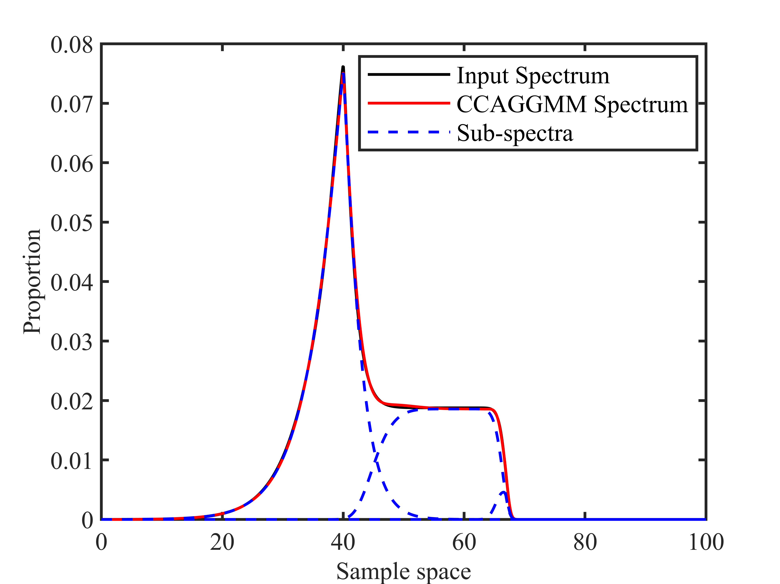
Figure 1. Spectral decomposition results of Example 1 by CCAGGMM.
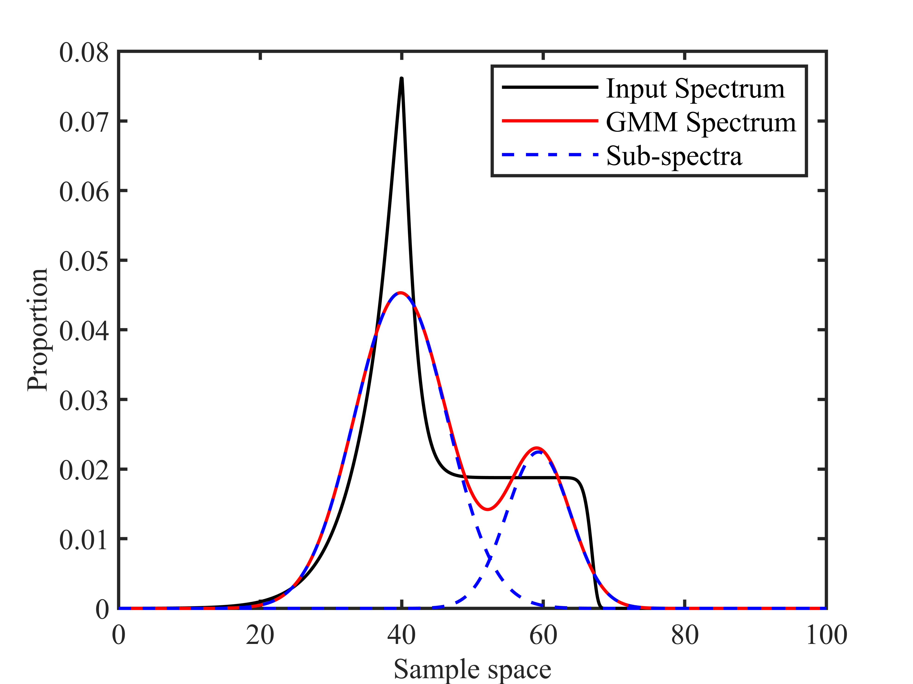
Figure 2. Spectral decomposition results of Example 1 by GMM.
2) Example 2
(1) The input spectrum is stored in the file "Example 2 (Figure.5(SNR=30dB))-input spectrum". Specify the full path of this file and replace line 12 of "spectrum_decomposition_main.m" with the full path of this file.
(2) Replace lines 13–38 in the main function with the codes from the file "Example 2 (Figure.5(SNR=30dB) with constraint)-input parameters".
(3) Run the program to obtain the output parameter "CCAGGMM_para_new" (in the files of "Example 2 (Figure.5(SNR=30dB) with constraint)-outputs"), which store the parameters of each sub-spectrum obtained after spectral decomposition (Table 6). The subroutine "GP_CCAGGMM.m" plot these results as shown in Figure 3.
(4) Replace lines 13–38 in the main function with the codes from the file "Example 2 (Figure.5(SNR=30dB) without constraint)-input parameters".
(5) Run the program to obtain the output parameters “CCAGGMM_para_new” (in the files of "Example 2 (Figure.5(SNR=30dB) without constraint)-outputs"), which store the parameters of each sub-spectrum obtained after spectral decomposition (Table 7). The subroutine "GP_CCAGGMM.m" plot these results as shown in Figure 4.
Table 6. Output sub-spectra parameters of Example 2 obtained by CCAGGMM (confidence-constrained).
Sub-spectrum | 1 | 2
Weight | 0.56 | 0.43
Expectation | 40.10 | 60.84
Left branch scale factor | 5.52 | 18.21
Right branch scale factor | 2.28 | 6.15
Shape factor | 1.14 | 9.64
Table 7. Output sub-spectra parameters of Example 2 obtained by CCAGGMM without confidence-constraint.
Sub-spectrum | 1 | 2
Weight | 0.75 | 0.25
Expectation | 39.04 | 63.76
Left branch scale factor | 4.18 | 13.89
Right branch scale factor | 5.70 | 3.17
Shape factor | 0.90 | 5.10
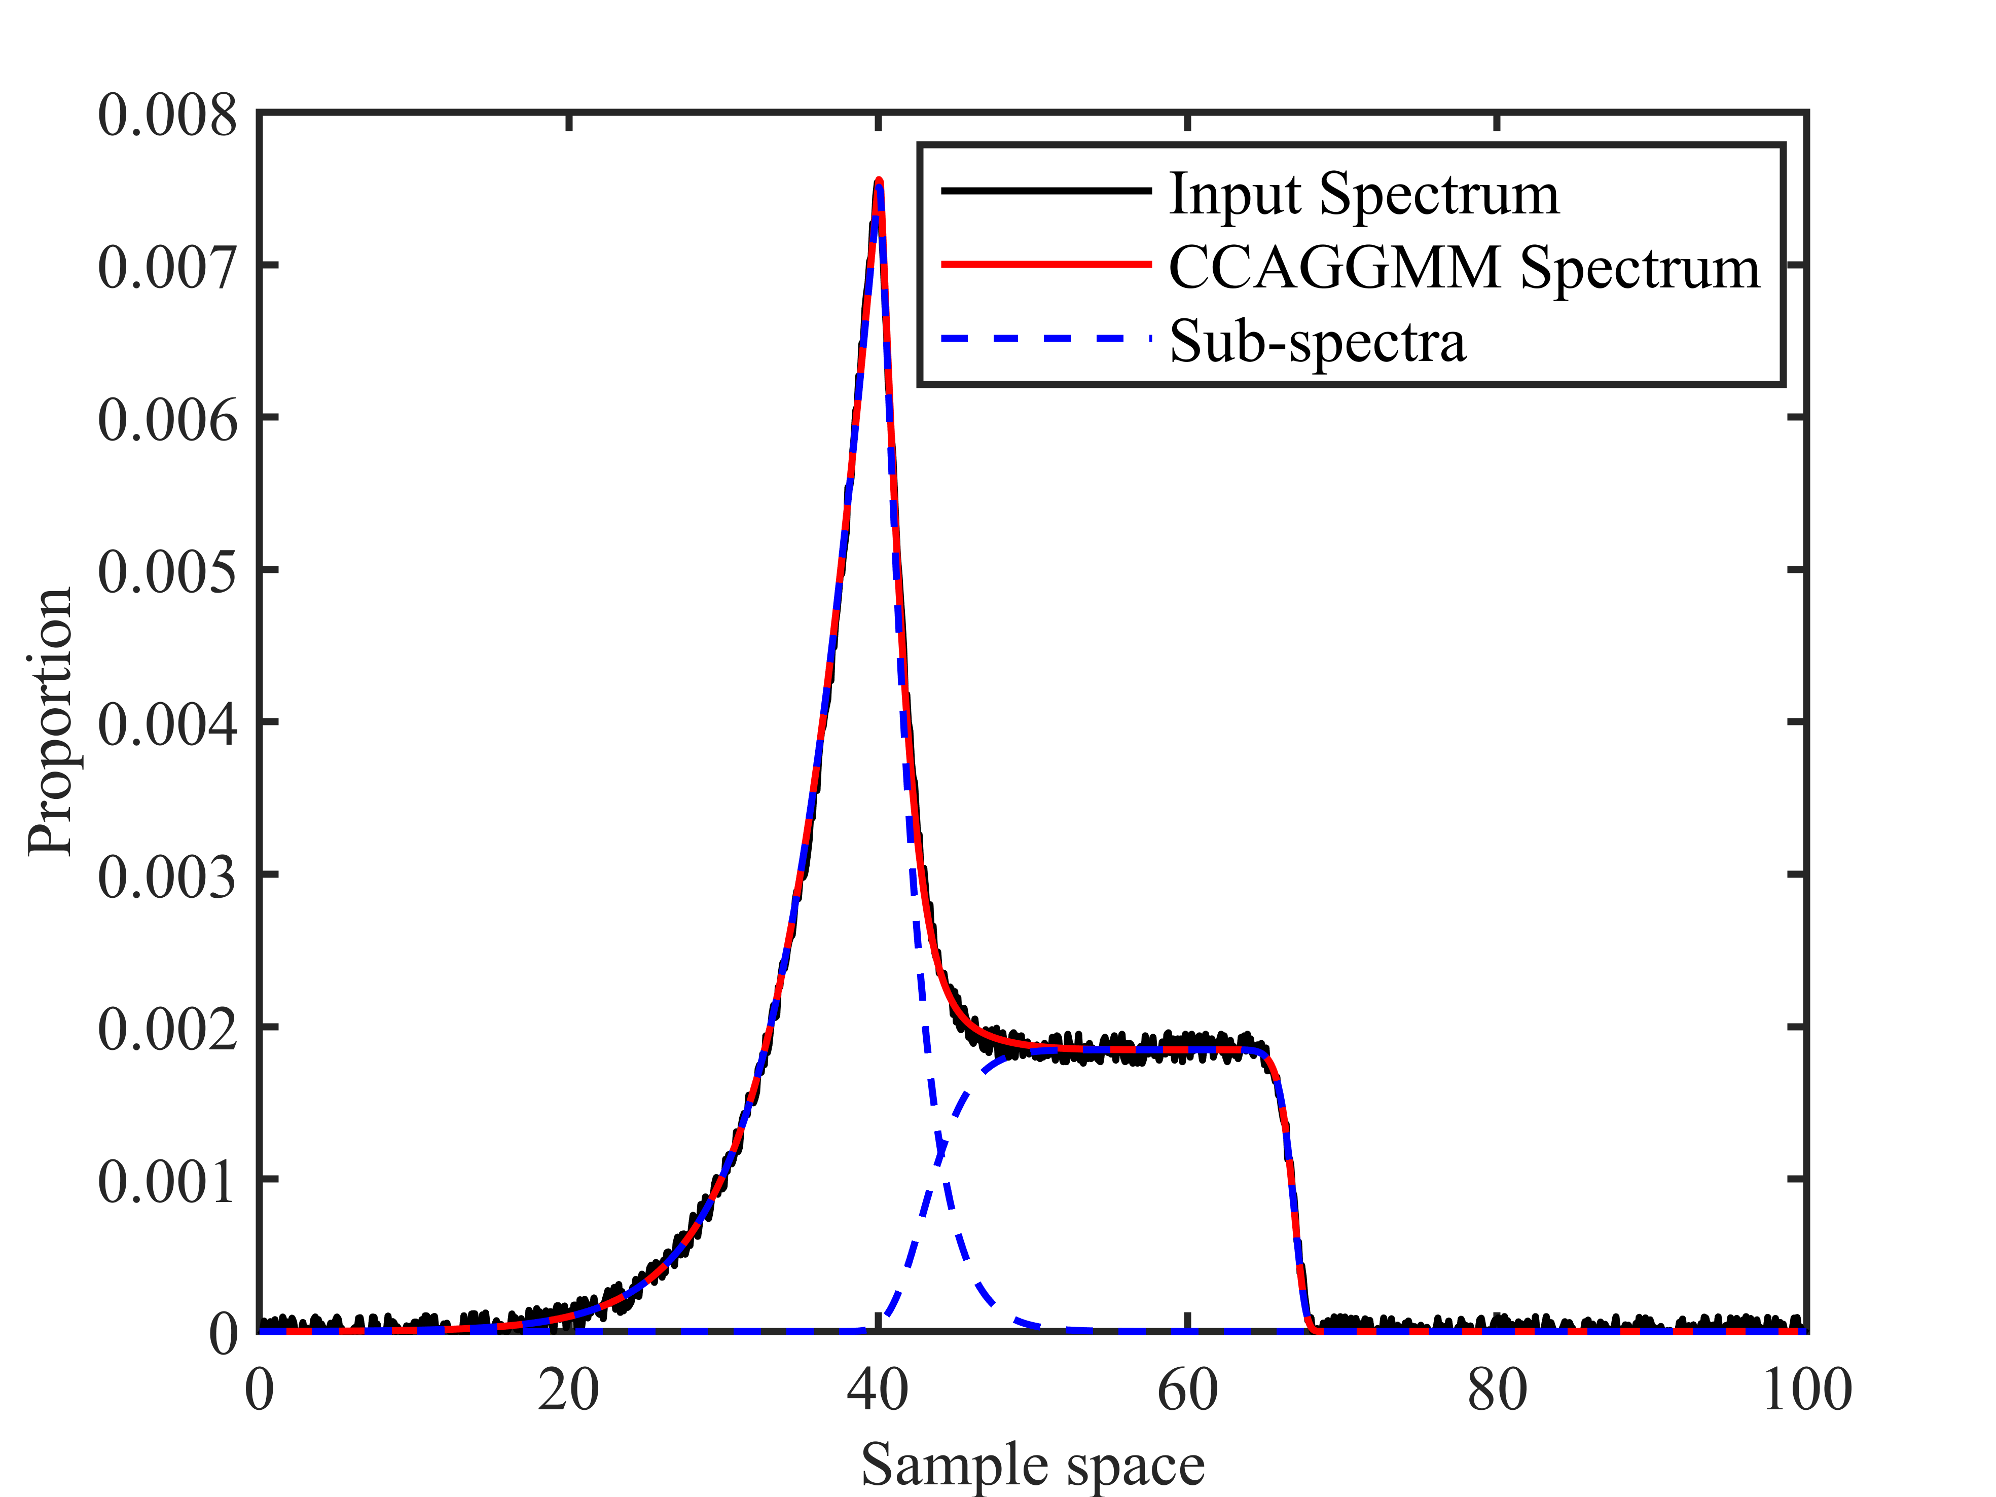
Figure 3. Spectral decomposition results of Example 2 by CCAGGMM with constrained.
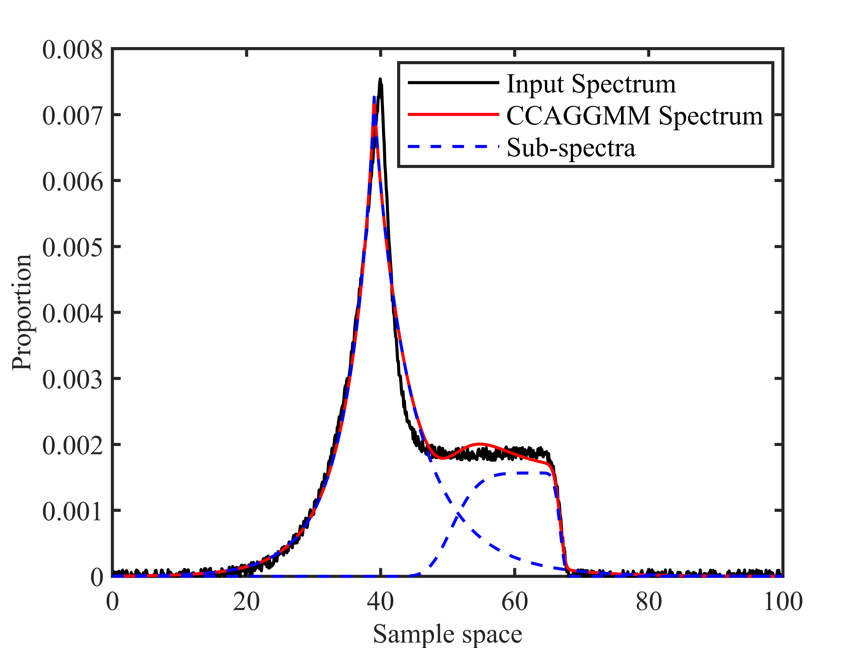
Figure 4. Spectral decomposition results of Example 2 by CCAGGMM without constrained.

3) Example 3
(1) The input spectrum is stored in the file "Example 3 (Figure.6(a))-input spectrum". Specify the full path of this file and replace line 12 of "spectrum_decomposition_main.m" with the full path of this file.
(2) Replace lines 13–38 in the main function with the codes from the file "Example 3 (Figure.6(a))-input parameters".
(3) Run the program to obtain the output parameter "CCAGGMM_para_new" (in the file of "Example 3 (Figure.6(a))-outputs"), which stores the parameters of each sub-spectrum obtained after spectral decomposition (Table 8). The subroutine "GP_CCAGGMM.m" plots these results as shown in Figure 5.

Table 8. Output sub-spectra parameters of Example 3 obtained by CCAGGMM decomposition.
Sub-spectrum | 1 | 2 | 3
Weight | 0.13 | 0.67 | 0.20
Expectation | 48.23 | 61.88 | 84.97
Left branch scale factor | 10.90 | 10.01 | 5.26
Right branch scale factor | 5.61 | 8.83 | 2.74
Shape factor | 2.33 | 2.81 | 3.31
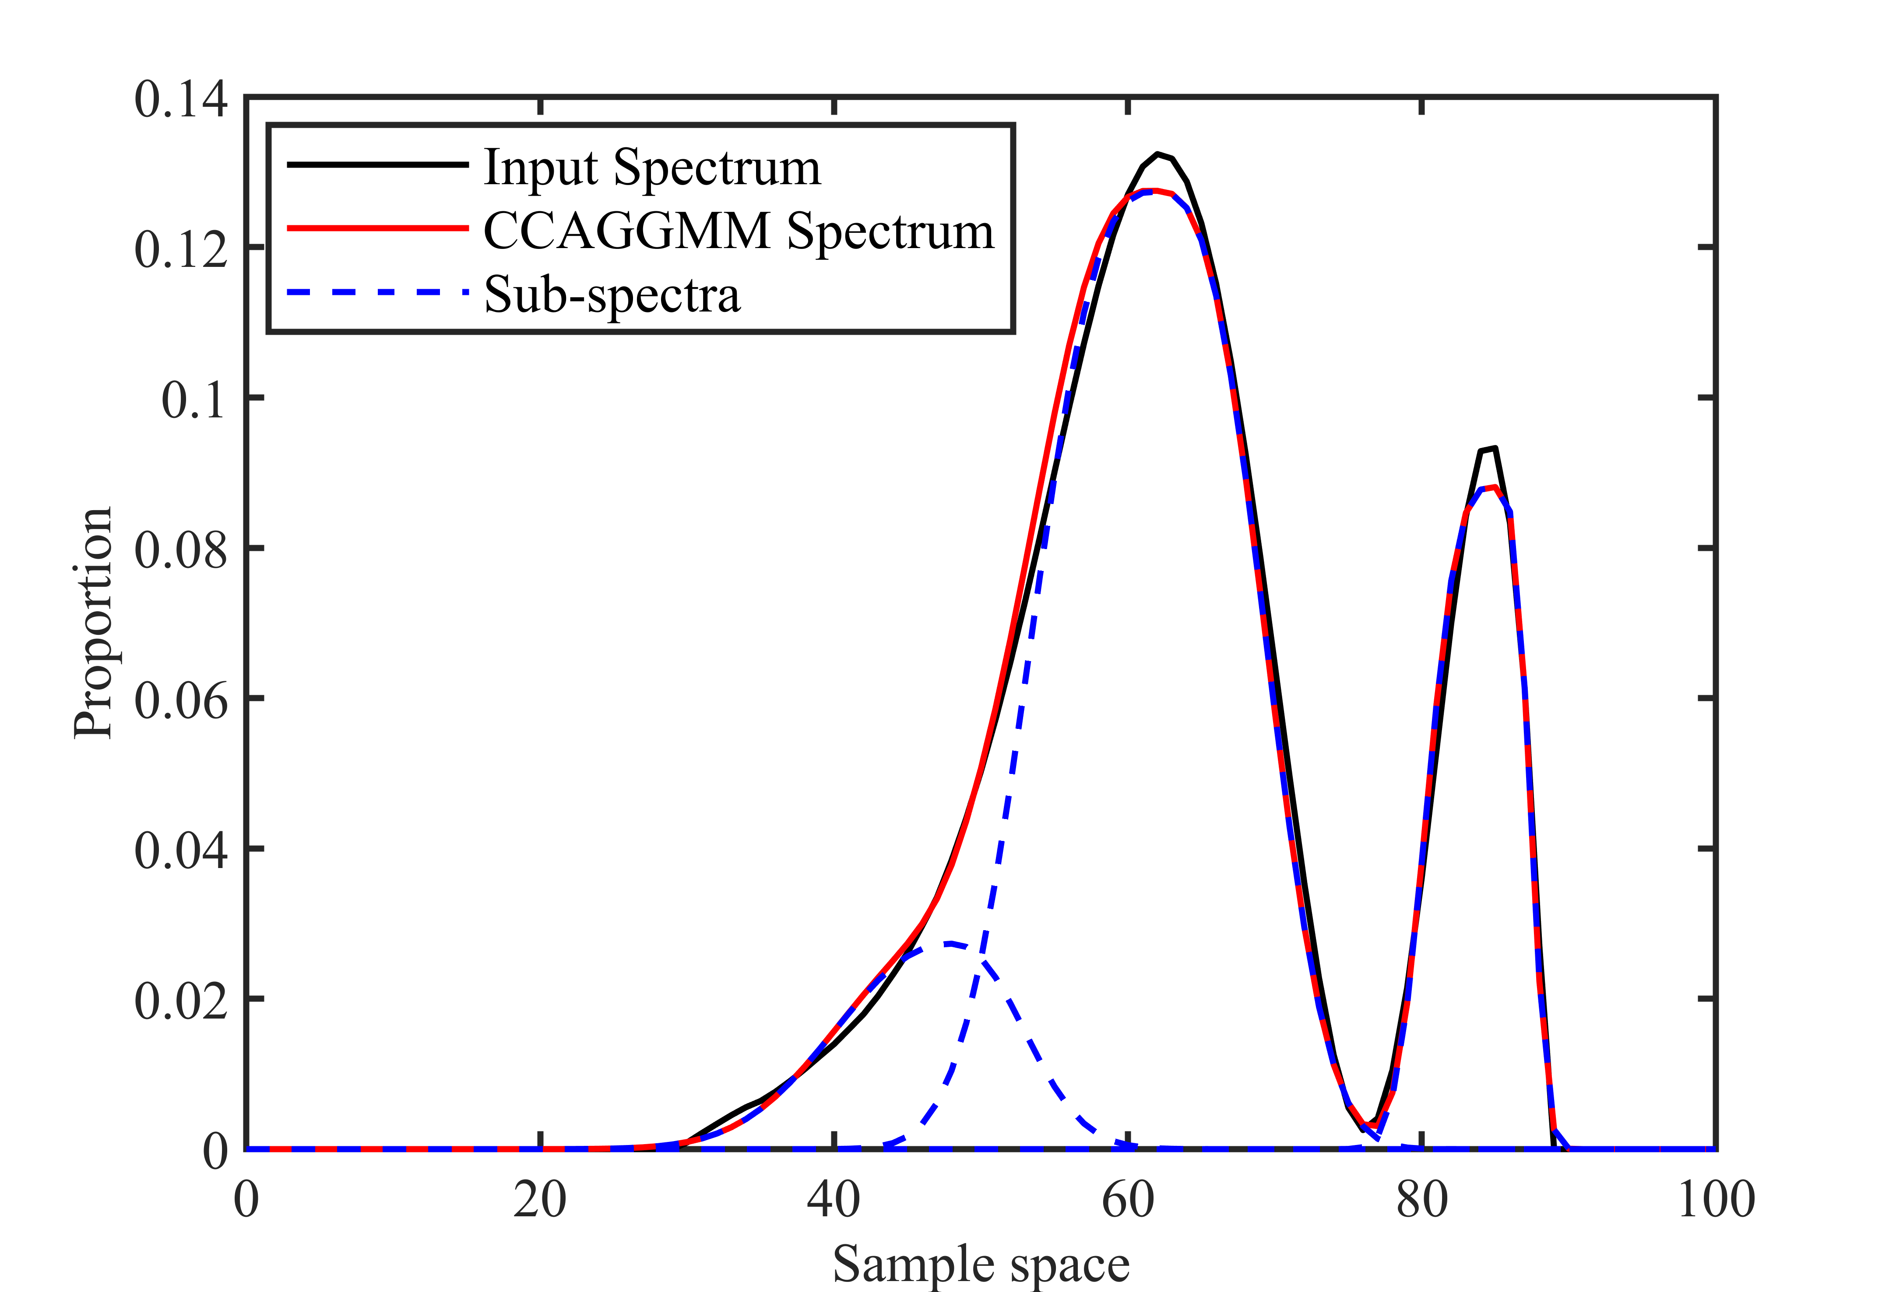
Figure 5. Spectral decomposition results of Example 3.

